|  |
| --- |
| IFMR RURAL FINANCE |
| Field Appraisal |
|  |
| **IFMR Rural Finance** |
| **10/23/2016** |

|  |
| --- |
|  |

Contents

Process Diagram 3

1. Stage definition 4

2. Stage-role access 4

3. Field Appraisal Queue 4

3.1 UI specification 4

3.2 Screenshot 5

3.3 Functional requirements 6

3.4 Upload 6

3.5 Download 6

3.6 Reports 6

4. Capturing Field Appraisal data 7

4.1 UI requirements 7

4.2 Screenshots 46

4.3 Functional requirements 73

4.4 Uploads 73

4.5 Downloads 73

4.6 Reports 73

5. Risk Score 2 73

5.1 UI specification 73

5.2 Screenshot 73

5.3 Functional requirements 73

5.4 Upload 73

5.5 Download 73

5.6 Reports 73

# Process

## 1.1 PROCESS DIAGRAM

E:\sarthak.shah\Desktop\Field Appraisal V3.png

## PROCESS STEPS

1. Field Risk Officer logs in and is able to view all profiles that completed Application Stage.
2. FRO can search profiles based on the following criteria
   * + Applicant Name
     + Business Name
     + URN Number
     + Area
     + City /Village/Town
3. All search parameters except pin-code will have a sort/arrange facility
4. FRO will click on the desired profile to select the customer. Data of that customer will be auto-populated and all the fields will be displayed.
5. FRO is supposed to fill proxy indicators and capture remarks if any.
6. Then FRO is supposed to take decision on whether to accept/reject/send back/hold.
7. If accept then Calculate risk score and send the application to Field appraisal review stage.
8. If Reject then system will reject the application after capturing rejection remarks.
9. If Hold the applicant will be added back to the Field Appraisal Queue.
10. If Send back then he is supposed to select screening/application stage where application has to be sent back.

# Stage definition

|  |  |
| --- | --- |
| **Stage** | **Description** |
| Field Appraisal Queue | The Field Risk Officer selects a profile from the application review completed list |
| Capture Details | The Field Risk Officer captures data and submits the same for risk score calculation |
| Risk Score | System to calculate risk score based on logic and send loan for central credit review |

# Stage-role access

|  |  |
| --- | --- |
| **Stage** | **Applicable Role** |
| Field Appraisal Queue | Field Risk Officer |
| Capture Details | Field Risk Officer |
| Risk Score | -NA- |

# Field Appraisal Queue

## UI specification

|  |  |  |  |  |
| --- | --- | --- | --- | --- |
| **Field name** | **Section** | **Data Type** | **Attribute** | **Population logic** |
| Applicant Name | Field Appraisal Queue | Text | Sort/search | From application stage |
| Business Name | Field Appraisal Queue | Alphanumeric | Sort/search | From application stage |
| URN No | Field Appraisal Queue | Alphanumeric | Sort/search | From application stage |
| Area | Field Appraisal Queue | Text | Sort/search | From application stage |
| City/Village/ Town | Field Appraisal Queue | Text | Sort/search | From application stage |
| Pincode | Field Appraisal Queue | Numeric |  | From application stage |

## Screenshot

* + 1. Search Page

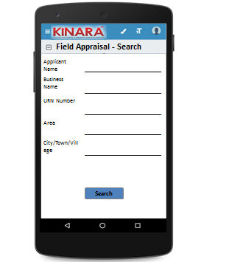

* + 1. Field Appraisal Queue

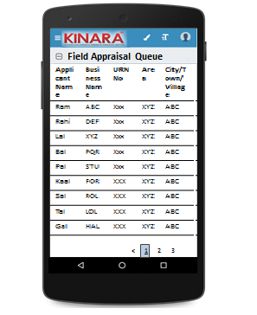

## Functional requirements

**Field Risk Officer (FRO)** logs in

* The FRO opens the process dash board, and clicks on Field Appraisal queue
* If the FRO performs a search without selecting any parameter, then all cases with status ‘Pending for Field Appraisal’ to be displayed in a tabular format.
* If the FRO searches with ‘Applicant name’, ‘Business name’ or ‘URN no’, then all matching records that are ‘Pending for Field Appraisal’ (including existing customers) to be displayed in a tabular format.
* The FRO can **search and sort** the profiles based on the following parameters: URN no, Applicant Name, Business Name, Area, City/Village/Town.
* The FRO then selects a profile from the field appraisal queue. The queue table should have applicant name, business name, URN No, Area, City/Town/Village as column names.
* All the columns will have **sorting** facility.

## Upload

-NA-

## Download

-NA-

## Reports

-NA-

# Capturing Field Appraisal data

## UI requirements

|  |  |  |  |  |  |  |  |  |
| --- | --- | --- | --- | --- | --- | --- | --- | --- |
| **Entity** | **Tab** | **Sub tab** | **Section** | **Fields** | **Field Value** | **Mandatory** | **Conditional Mandatory** | **Remarks** |
| APPLICANT | KYC Details |  |  | Aadhar No | Numeric | Yes |  | Aadhar -QR Code Scan (Auto fill Profile & Address data)- from application |
| Document Capture | Upload | Yes |  | from application |
| Pan Number | Alpha numeric | Yes |  | from application |
| Document Capture | Upload | Yes |  | from application |
| ID Type | Dropdown |  |  | Ration Card, Voter Card, Passport, Pan Card, Aadhar card, Driving License |
| ID No | Alpha numeric |  | Yes | If ID type selected- from application |
| Valid Up to | Date |  |  | If ID type selected- from application |
| Document Capture | Upload |  | Yes | If ID type selected- from application |
| Add Button |  |  |  |  |
| Applicant Details |  |  | Title | Text | Yes |  | Aadhar QR Code scanning- from application |
| Name | Text | Yes |  | Aadhar QR Code scanning- from application |
| Gender | Text | Yes |  | Aadhar QR Code scanning- from application |
| Date Of birth | Text | Yes |  | Aadhar QR Code scanning- from application |
| Age | Text |  |  | if age<25 years, then co-app/Guarantor is required- - from application |
| Father's Name | Text | Yes |  | from application |
| Educational Level | Dropdown | Yes |  | Below SSLC, SSLC, HSC, Graduate/Diploma/ITI, Professional Degree, Others |
| Religion | Dropdown | Yes |  | Hindu, Muslim, Christian, Jain, Buddhist, Others |
| Mobile No | Numeric | Yes |  | from application |
| Alternative Mobile No. | Numeric |  |  | from application |
| Whatsapp Mobile No. | Radio Buttons |  |  | Radio buttons – same as mobile no./same as alternate no./other – free text |
| Email ID | Alphanumeric, special characters |  |  | from application |
| Preferred language of communication | Dropdown | Yes |  | Hindi, English, Kannada, Malayalam, Gujarati, Marathi, Tamil, Bengali, Odia, Punjabi, Marwari |
| Mother's Name | Text |  |  | from application |
| Marital Status | Dropdown | Yes |  | Divorced,Separated, Single, Married, Widow |
| if single, then co-app/Guarantor is required- from application |
| Spouse Name | Text |  |  | from application |
| Relationship with Business | Dropdown | Yes |  | Proprietor, Partner, Director, Others - from application |
| Business Involvement | Dropdown | Yes |  | Full Time, Part Time, None if biz involvement is not fulltime, then co-app required- from application |
| Have you ever been a proprietor or partner of any other company | Radio Buttons |  |  | Yes/NO-from application |
| If yes, did the business close? | Radio Buttons |  |  | Yes/NO-from application |
| Month/Year (of business closure) | Date |  |  | MM/YYYY Format- from application |
| Address Details |  |  | Type Of Address | Dropdown | Yes |  | Permanent, Communication, As per Aadhar card-from application |
| Care of | Text |  |  | from application |
| Building | Alphanumeric, special characters | Yes |  | from application |
| Street | Alphanumeric, special characters |  |  | from application |
| Landmark | Alphanumeric, special characters |  |  | from application |
| Locality | Alphanumeric, special characters |  |  | from application |
| Pincode | Text | Yes |  | Pincode search |
| Village/Town/City | Text | Yes |  | Auto-fill from Pincode master |
| District | Text | Yes |  | Auto-fill from Pincode master |
| State | Numeric | Yes |  | Auto-fill from Pincode master |
| Country | Text | Yes |  | from application |
| Location | GPS coordinates |  |  |  |
| Is the Communication Address same as the Aadhar Card address? | Radio Buttons | Yes |  | Yes/No |
| from application |
| Line 1 | Alpha numeric |  | Yes | Populate if communication address is different from Aadhar card--from application |
| Line 2 | Alpha numeric |  |  | Populate if communication address is different from Aadhar card--from application |
| Area | Alpha numeric |  |  | Populate if communication address is different from Aadhar card--from application |
| Land Mark | Alpha numeric |  | Yes | Populate if communication address is different from Aadhar card--from application |
| Pincode | Numeric |  | Yes | Populate if communication address is different from Aadhar card--from application |
| State | Text |  | Yes | Auto populated based on Pincode; Populate if communication address is different from Aadhar card-- from application |
| District | Text |  | Yes | Auto populated based on Pincode; Populate if communication address is different from Aadhar card-- from application |
| City/Town/Village | Text |  | Yes | Auto populated based on Pincode; Populate if communication address is different from Aadhar card-- from application |
| Landline Number | Numeric |  |  |  |
| Ownership | Dropdown | Yes |  | Own, Rent, Lease |
| -from application |
| How many years are you living in present Area? | Dropdown | Yes |  | Less than 1 year, 1 to 3 years, 4 to 6 years, 6 to 10 years, greater than 10 years-from application |
| How many years are you living in current Address? | Dropdown | Yes |  | Less than 1 year, 1 to 3 years, 4 to 6 years, 6 to 10 years, greater than 10 years-from application |
| Is the Communication Address same as Permanent Address? | Radio Buttons | Yes |  | Yes/No- If no, populate same fields to capture permanent Address-from application |
| Family Member Details |  |  | Name | Text |  |  |  |
| Relationship with applicant | Dropdown |  |  | Kinara to provide |
| Profession | Dropdown |  |  | Kinara to provide |
| Salary | numeric |  |  |  |
| Education fee (annual) | numeric |  |  |  |
| Is a Co-applicant? | Radio Buttons |  |  | YES/NO |
| **Button to add additional family members** |  |  |  |  |
| Household Financials |  |  | Other Income Source | Dropdown |  |  | Kinara to provide |
| Amount | Numeric |  |  |  |
| **Add button** |  |  |  |  |
| Expense Type | Dropdown |  |  | Kinara to provide |
| Amount | Numeric |  |  |  |
| **Add button** |  |  |  |  |
| Monthly Education Expenses | Auto Calculated |  |  | Based on education fees captured in family member details |
| Family Exp. Based on Education expense | Auto Calculated |  |  | Multiply the education fees with 20/3 |
| Asset Type | Dropdown |  |  | House, Land, Two wheeler, Four wheeler |
| Vehicle make & model | Alphanumeric |  | Yes | If two or four wheeler selected then display this field |
| Registered Owner | Alpha |  | Yes | Display only If Asset type is selected |
| Value of the asset | Numeric |  | Yes | Display only If Asset type is selected |
| **Add button** |  |  |  |  |
| Liabilities |  |  | Debt Source | Dropdown |  |  | Kinara to provide |
| Creditor's Name | Alphanumeric |  |  |  |
| Loan Amount | Numeric |  |  |  |
| Loan Outstanding | Numeric |  |  |  |
| Loan term | Alphanumeric |  |  |  |
| Monthly Instalment | Numeric |  |  |  |
| No. of instalment Paid | Numeric |  |  |  |
| Purpose | Dropdown |  |  | Machine Refinance, Asset Purchase, Debt Consolidation, Working Capital, Line Of Credit, Business Development |
| **Button to add liabilities** |  |  |  |  |
| Bank Statement Details |  |  | IFSC Code | Alphanumeric | Yes |  | IFSC code search |
| Bank Name | Alphanumeric |  |  | Auto fill from IFSC code search |
| Branch Name | Text |  |  | Auto fill from IFSC code search |
| A/C name | Alphanumeric | Yes |  | from application |
| A/C type | Text | Yes |  | from application |
| A/C no | Numeric | Yes |  | from application |
| Banking since | Date |  |  | MM/YYYY Format  from application |
| Net banking available | Radio Buttons | Yes |  | Yes/No (from application) |
| Sanctioned Amount | Numeric |  | Yes | (If A/C type is OD, CC)- from application |
| Start Month | Date | Yes |  | from application |
| Total Deposits | Numeric | Yes |  | from application |
| Total Withdrawals | Numeric | Yes |  | from application |
| Balance as on 15th | Numeric | Yes |  | from application |
| Add Button |  |  |  | Provide an option to enter month wise details of start month, Total Deposits, Total Withdrawals, Balance as on 15th |
| No of cheques bounced | Numeric | Yes |  | from application |
| No of EMI cheques bounced | Numeric | Yes |  | from application |
| **Button to add account** |  |  |  |  |
| References |  |  | Reference Type | Dropdown | Yes |  | Personal-Neighbour, Personal-Relative/friend |
| Full Name | Alphanumeric |  |  |  |
| Mobile No | Numeric |  |  |  |
| Occupation | Dropdown |  |  | Kinara to provide |
| Self-reported Income | Numeric |  |  |  |
| Add Button |  |  |  |  |
| Proxy Indicators |  |  | Proper & Matching Signboard | Radio Buttons | Yes |  | Yes/No |
| Bribe Offered | Radio Buttons | Yes |  | Yes/No |
| Shop/Shed Organized | Radio Buttons | Yes |  | Ok/Good/Poor |
| In Industrial Area | Radio Buttons | Yes |  | Yes/No |
| Customer Attitude to Kinara | Radio Buttons | Yes |  | Ok/Good/Poor -- (auto -reject if Poor) |
| Book-keeping Quality | Radio Buttons | Yes |  | Ok/Good/Poor |
| Challenging cheque bounce/fee charge/policies | Radio Buttons | Yes |  | Yes/No |
| All Machines operational? | Radio Buttons | Yes |  | Yes/No |
| Employee Satisfaction | Radio Buttons | Yes |  | Ok/Good/Poor |
| Political/Police Connections | Radio Buttons | Yes |  | Yes/No -- (auto-reject if yes) |
| Multiple Products (more than 3) | Radio Buttons | Yes |  | Yes/No |
| Multiple Buyers (more than 3) | Radio Buttons | Yes |  | Yes/No |
| Seasonal Business | Radio Buttons | Yes |  | Yes/No |
| Income Stability | Radio Buttons | Yes |  | Stable/ Decreasing Trend/ Increasing trend/ Fluctuating |
| Utilization of business premises | Radio Buttons | Yes |  | Good/Average/Poor |
| Approach for the business premises | Radio Buttons | Yes |  | Good Connectivity, Bad Connectivity |
| Safety measures for employees | Radio Buttons | Yes |  | Good/Average/Poor |
| Child labourers | Radio Buttons | Yes |  | Yes/No |
| Is the business in effecting environment? | Radio Buttons | Yes |  | Yes/No |
| Stock/material management | Radio Buttons | Yes |  | Good/Average/Poor |
| CO-APPLICANT | KYC Details |  |  | Aadhar No | Numeric | Yes |  | Aadhar -QR Code Scan (Auto fill Profile & Address data)- from application |
| Document Capture | Upload | Yes |  | from application |
| Pan Number | Alpha numeric | Yes |  | from application |
| Document Capture | Upload | Yes |  | from application |
| ID Type | Dropdown |  |  | Ration Card, Voter Card, Passport, Pan Card, Aadhar card, Driving License |
| ID No | Alpha numeric |  | Yes | If ID type selected- from application |
| Valid Up to | Date |  |  | If ID type selected- from application |
| Document Capture | Upload |  | Yes | If ID type selected- from application |
|  |  |  | Add Button |  |  |  | In Case more than one ID card then use this button. Populate ID Type, ID No, Valid Up to and Document Capture again |
| Co-Applicant Details |  |  | Title | Text | Yes |  | Aadhar QR Code scanning- from application |
| Name | Text | Yes |  | Aadhar QR Code scanning- from application |
| Gender | Text | Yes |  | Aadhar QR Code scanning- from application |
| Date Of birth | Date | Yes |  | Aadhar QR Code scanning- from application |
| Age | Numeric |  |  | Auto Calculate based on Date Of Birth entered |
| if age<25 yrs, then co-app/Guarantor is required- - from application |
| Father's Name | Text | Yes |  | from application |
| Educational Level | Dropdown | Yes |  | Below SSLC, SSLC, HSC, Graduate/Diploma/ITI, Professional Degree, Others- -- from application |
| Religion | Dropdown | Yes |  | Hindu, Muslim, Christian, Jain, Buddhism, Others-- - from application |
| Mobile No | Numeric | Yes |  | from Screening |
| Alternative Mobile No. | Numeric |  |  | from application |
| Whatsapp Mobile No. | Radio Buttons |  |  | Radio buttons – same as mobile no./same as alternate no./other – free text |
| Email ID | Alphanumeric, special characters |  |  | from application |
| Preferred language of communication | Dropdown | Yes |  | Hindi, English, Kannada, Malayalam, Gujarati, Marathi, Tamil, Bengali, Odia, Punjabi, Marwari |
| from application |
| Mothers Name | Text |  |  | from application |
| Marital Status | Dropdown | Yes |  | Divorced,Separated, Single, Married, Widow |
| if single, then co-app/Guarantor is required- from application |
| Spouse Name | Text |  | Yes | If married selected then display this field too. |
| from application |
| Relationship with Applicant | Dropdown | Yes |  | Spouse, Sibling, Parent, Child, Friend, Others-from application |
| Relationship with Business | Dropdown | Yes |  | Proprietor, Partner, Director, Others (not to be populated for guarantor)- from application |
| Business Involvement | Dropdown | Yes |  | Full Time, Part Time, None |
| Have you ever been a proprietor or partner of any other company | Radio Buttons |  |  | Yes/No (from application) |
| If yes, did the business close? | Radio Buttons |  |  | from application |
| Month/Year (of business closure) | Date |  |  | MM/YYYY format (from application) |
| Address Details |  |  | Type Of Address | Dropdown | Yes |  | Permanent, Communication, As per Aadhar card-from application |
| Care of | Text |  |  | from application |
| Building | Alphanumeric, special characters | Yes |  | from application |
| Street | Alphanumeric, special characters |  |  | from application |
| Landmark | Alphanumeric, special characters |  |  | from application |
| Locality | Alphanumeric, special characters |  |  | from application |
| Pincode | Text | Yes |  | Pincode search |
| Village/Town/City | Text | Yes |  | Auto-fill from Pincode master |
| District | Text | Yes |  | Auto-fill from Pincode master |
| State | Numeric | Yes |  | Auto-fill from Pincode master |
| Country | Text | Yes |  | from application |
| Location | GPS coordinates |  |  |  |
| Is the Communication Address same as the Aadhar Card address? | Radio Buttons | Yes |  | Yes/No |
| from application |
| Line 1 | Alpha numeric |  | Yes | Populate if communication address is different from aadhar card--from application |
| Line 2 | Alpha numeric |  |  | Populate if communication address is different from aadhar card--from application |
| Area | Alpha numeric |  |  | Populate if communication address is different from aadhar card--from application |
| Land Mark | Alpha numeric |  | Yes | Populate if communication address is different from aadhar card--from application |
| Pincode | Numeric |  | Yes | Populate if communication address is different from aadhar card--from application |
| State | Auto populated |  | Yes | Auto populated based on Pincode; Populate if communication address is different from aadhar card--from application |
| District | Auto populated |  | Yes | Auto populated based on Pincode; Populate if communication address is different from aadhar card--from application |
| City/Town/Village | Auto populated |  | Yes | Auto populated based on Pincode; Populate if communication address is different from aadhar card--from application |
| Location (GPS) | GPS coordinates |  |  |  |
| Landline Number | Numeric |  |  |  |
| Ownership | Dropdown | Yes |  | Own, Rent, Lease |
| -from application |
| How many years are you living in present Area? | Dropdown | Yes |  | Less than 1 year, 1 to 3 years, 4 to 6 years, 6 to 10 years, greater than 10 years-from application |
| How many years are you living in current Address? | Dropdown | Yes |  | Less than 1 year, 1 to 3 years, 4 to 6 years, 6 to 10 years, greater than 10 years-from application |
| Is the Communication Address same as Permanent Address? | Radio Buttons | Yes |  | Yes/No- If no, populate same fields to capture permanent Address-from application |
|  |  |  | Debt Source | Dropdown |  |  | Kinara to provide |
| Liabilities |  |  | Creditor's Name | Alphanumeric |  |  |  |
|  |  | Loan Amount | Numeric |  |  |  |
|  |  | Loan Outstanding | Numeric |  |  |  |
|  |  | Loan term | Alphanumeric |  |  |  |
|  |  | Monthly Instalment | Numeric |  |  |  |
|  |  | No. of instalment Paid | Numeric |  |  |  |
|  |  | Purpose | Dropdown |  |  | Machine Refinance, Asset Purchase, Debt Consolidation, Working Capital, Line Of Credit, Business Development |
|  |  | **Button to add liabilities** |  |  |  |  |
| Family Member Details |  |  | Name | Text |  |  |  |
| Relationship with co-applicant | Text |  |  | Kinara to provide |
| Profession | Text |  |  | Kinara to provide |
| Salary | Numeric |  |  |  |
| Education fee (annual) | Numeric |  |  |  |
| **Buttons to add additional family members** |  |  |  |  |
| Household Financials |  |  | Other Income Source | Dropdown |  |  | Kinara to provide |
| Amount | Numeric |  |  |  |
| **Add button** |  |  |  |  |
| Expense Type | Dropdown |  |  | Kinara to provide |
| Amount | Numeric |  |  |  |
| **Add button** |  |  |  |  |
| Monthly Education Expenses | Auto Calculated |  |  | Based on family details captured |
| Family Exp. Based on Education expense | Auto Calculated |  |  | Multiply monthly education Expenses with (20/3) |
| Asset Type | Dropdown |  |  | House, Land, Two wheeler, Four wheeler |
| Vehicle make & model | Alphanumeric |  | Yes | If two or four wheeler is selected |
| Registered Owner | Alpha |  | Yes | If asset type is selected |
| Value of the asset | Numeric |  | Yes | If asset type is selected |
| **Add button** |  |  |  |  |
| Bank Statement Details |  |  | IFSC Code | Alphanumeric | Yes |  | IFSC code search |
| Bank Name | Alphanumeric |  |  | Auto fill from IFSC code search |
| Branch Name | Text |  |  | Auto fill from IFSC code search |
| A/C name | Alphanumeric | Yes |  | from application |
| A/C type | Text | Yes |  | from application |
| A/C no | Numeric | Yes |  | from application |
|
| Banking since | Date |  |  | MM/YYYY format |
| from application |
| Net banking available | Radio Buttons | Yes |  | Yes/No |
| from application |
| Sanctioned Amount | Numeric |  | Yes | (If A/C type is OD, CC)- from application |
| Start Month | Date | Yes |  | from application |
| Total Deposits | Numeric | Yes |  | from application |
| Total Withdrawals | Numeric | Yes |  | from application |
| Balance as on 15th | Numeric | Yes |  | from application |
| Add Button |  |  |  | Add monthly details. Populate start month, Total Deposits, Total Withdrawals and balance as on 15th again. |
| No of cheques bounced | Numeric | Yes |  | from application |
| No of EMI cheques bounced | Numeric | Yes |  | from application |
| **Button to add account** |  |  |  |  |
| GUARANTOR | KYC Details |  |  | Aadhar No | Numeric | Yes |  | Aadhar -QR Code Scan (Auto fill Profile & Address data)- from application |
| Document Capture | Upload | Yes |  | from application |
| Pan Number | Alpha numeric | Yes |  | from application |
| Document Capture | Auto populate/Upload | Yes |  | from application |
| ID Type | Dropdown |  |  | refer to screening dropdown sheet- from application |
| ID No | Alpha numeric |  | Yes | If ID type selected- from application |
| Valid up to | Date |  |  | If ID type selected- from application |
| Document Capture | Upload |  | Yes | If ID type selected- from application |
| **Add Button** |  |  |  |  |
| Guarantor Details |  |  | Title | Text | Yes |  | Aadhar QR Code scanning- from application |
| Name | Text | Yes |  | Aadhar QR Code scanning- from application |
| Gender | Text | Yes |  | Aadhar QR Code scanning- from application |
| Date Of birth | Date | Yes |  | Aadhar QR Code scanning- from application |
| Age | Numeric |  |  | Auto Calculate based on Date of birth- - from application |
| Father's Name | Text | Yes |  | from application |
| Educational Level | Dropdown | Yes |  | Below SSLC, SSLC, HSC, Graduate/Diploma/ITI, Professional Degree, Others |
| Religion | Dropdown | Yes |  | Hindu, Muslim, Christian, Jain, Buddhist, Others |
| Mobile No | Numeric | Yes |  | from application |
| Alternative Mobile No. | Numeric |  |  | from application |
| Whatsapp Mobile No. | Radio Buttons |  |  | Radio buttons – same as mobile no./same as alternate no./other – free text |
| Email ID | Alphanumeric, special characters |  |  | from application |
| Preferred language of communication | Dropdown | Yes |  | Hindi, English, Kannada, Malayalam, Gujarati, Marathi, Tamil, Bengali, Odia, Punjabi, Marwari |
| Mother's Name | Text |  |  | from application |
| Marital Status | Dropdown | Yes |  | Divorced,Separated, Single, Married, Widow- from application |
| Spouse Name | Text |  | Yes | If marital status is married -from application |
| Relationship with Applicant | Dropdown | Yes |  | Spouse, Sibling, Parent, Child, Friend, Others |
| Business Involvement | Dropdown | Yes |  | refer to screening dropdown sheet; if biz involvement is not fulltime, then co-app required- from application |
| Have you ever been a proprietor or partner of any other company | Radio Buttons |  |  | Yes/No |
| from application |
| If yes, did the business close? | Radio Buttons |  |  | Yes/No |
| from application |
| Month/Year (of business closure) | Date |  |  | MM/YYYY |
| from application |
| Address Details |  |  | Type Of Address | Dropdown | Yes |  | Permanent, Communication, As per Aadhar card-from application |
| Care of | Text |  |  | from application |
| Building | Alphanumeric, special characters | Yes |  | from application |
| Street | Alphanumeric, special characters |  |  | from application |
| Landmark | Alphanumeric, special characters |  |  | from application |
| Locality | Alphanumeric, special characters |  |  | from application |
| Pincode | Text | Yes |  | Pincode search |
| Village/Town/City | Text | Yes |  | Auto-fill from Pincode master |
| District | Text | Yes |  | Auto-fill from Pincode master |
| State | Numeric | Yes |  | Auto-fill from Pincode master |
| Country | Text | Yes |  | from application |
| Is the Communication Address same as the Aadhar Card address? | Radio Buttons | Yes |  | Yes/No |
| from application |
| Line 1 | Alpha numeric |  | Yes | Populate if communication address is different from Aadhar card--from application |
| Line 2 | Alpha numeric |  |  | Populate if communication address is different from Aadhar card--from application |
| Area | Alpha numeric |  |  | Populate if communication address is different from Aadhar card--from application |
| Land Mark | Alpha numeric |  | Yes | Populate if communication address is different from Aadhar card--from application |
| Pincode | Numeric |  | Yes | Populate if communication address is different from Aadhar card--from application |
| State | Auto populated |  | Yes | Auto populated based on Pincode; Populate if communication address is different from Aadhar card--from application |
| District | Auto populated |  | Yes | Auto populated based on Pincode; Populate if communication address is different from Aadhar card--from application |
| City/Town/ Village | Auto populated |  | Yes | Auto populated based on Pincode; Populate if communication address is different from Aadhar card--from application |
| Location (GPS) | GPS coordinates |  |  |  |
| Landline Number | Numeric |  |  |  |
| Ownership | Dropdown | Yes |  | Own, Rent, Lease (from application) |
| How many years are you living in present Area? | Dropdown | Yes |  | Less than 1 year, 1 to 3 years, 4 to 6 years, 6 to 10 years, greater than 10 years-from application |
| How many years are you living in current Address? | Dropdown | Yes |  | Less than 1 year, 1 to 3 years, 4 to 6 years, 6 to 10 years, greater than 10 years-from application |
| Is the Communication Address same as Permanent Address? | Radio Buttons | Yes |  | Yes/No- If no, populate same fields to capture permanent Address-from application |
| **Add Button to add another guarantor** | | | | | | | | |
| BUSINESS | Business Detail |  |  | Referred by | Dropdown | Yes |  | Cold Call, Existing customer Reference, Referral Partner - from application |
| Referred Name | Text |  | Yes (Based on the dropdown) | If it is cold call then referred name column should not show-from application |
| Business Name | Text | Yes |  | Auto populated from lead - but editable |
| Business type | Dropdown | Yes |  | Manufacturing, Trading, Services |
| Business Activity | Radio Buttons | Yes |  | If manufacturing -> Job work, Sales |
| If Trading ->Retail, Wholesale, |
| If Services->B2B, B2C |
| **Add Business Type** |  |  |  | In case of more than one business type. Populate business type and business activity again |
| Business Sector | Text | Yes |  | Auto populated from lead - but editable |
| Business Sub sector | Text | Yes |  | Auto populated from lead - but editable |
| ITR available? | Radio Buttons |  |  | Yes/No |
| from application |
| Business Operating since | Date |  |  | MM/YYYY |
| from application |
| Is the Business Registered? | Radio Buttons | Yes |  | Yes/No-from application |
| Business Registration Type | Dropdown |  | Yes | Tin, SSL No, VAT No, Business Pan Card No, Service Tax No, DIC, MSME, S&E, PAN (Mandatory if PVT LTD)(If business registered is yes) - from application |
| Business Registration Proof No | Alpha numeric |  | Yes | (If business registered is yes)- from application |
| Business Registration Date | Date |  | Yes | (If business registered is yes)- from application |
| Valid up to | Date |  | Yes | (If business registered is yes)- from application |
| **Add Business Registration Type button** |  |  |  | On click show Business Registration Type, Business registration Proof No, Business Registration Date, Valid up to and Document Capture again |
| Constitution | Dropdown |  |  | Proprietorship, Partnership, Private LTD |
| If partnership, how many total partners | Dropdown |  | Yes | 2; 3; 4; >4 (populate only for partnership)-from application |
| Has anyone else been a partner of your present business | Radio Buttons |  |  | Yes/No |
| from application |
| If yes, when was that partnership dissolved? | Date |  | Dissolution Agreement required | from application |
| Address Details |  |  | Line 1 | Alpha numeric | yes |  | Auto populated from lead - but editable |
| Line 2 | Alpha numeric |  |  | Auto populated from lead - but editable |
| Pin Code  (Search Option) | Numeric | yes |  | Auto populated based on Pincode- from application |
| Land Mark | Text | yes |  | Auto populated based on Pincode- from application |
| State (Auto populate) | Auto populated | yes |  | Auto populated based on Pincode- from application |
| District(Auto populate) | Auto populated | yes |  | Auto populated from lead - but editable |
| City/Village | Auto populated | yes |  | Auto populated from lead - but editable |
| Location (GPS) | GPS coordinates |  |  | from application |
| Landline Phone | Numeric | yes |  | from application |
| Ownership (Owned/Rent/Lease) | Dropdown | yes |  | refer to screening dropdown sheet-from application |
| How many years business in present Area? | Dropdown | yes |  | refer to screening dropdown sheet-from application |
| How many years business in current address? | Dropdown | yes |  | refer to screening dropdown sheet-from application |
| Employee Detail |  |  | No of Male Employees | Numeric |  |  |  |
| No of Female Employees | Numeric |  |  |  |
| Average Monthly Salary | Numeric |  |  |  |
| Buyer Detail |  |  | Buyer Name | Alpha numeric |  | Yes | Based on Sector definition buyer registration should be mandatory (Only applicable for manufacturing) |
| Customer Since | Dropdown |  | Yes |  |
| Sector | Dropdown |  | Yes |  |
| Sub Sector | Dropdown |  | Yes |  |
| Product | alpha numeric |  |  |  |
| Payment terms (days) | numeric |  |  |  |
| Payment date | Date |  |  |  |
| Payment Frequency | Dropdown |  |  | Kinara to provide |
| Receivables Outstanding / Customer Credit | numeric |  |  |  |
| **Add Button** |  |  |  |  |
| Business Financials | Income | Through Sales | Buyer Name | Dropdown |  |  | dropdown list Auto populated from buyer details-Add all the buyer's name here as a dropdown list |
| Income type | Radio Buttons |  |  | Cash/Invoice |
| Amount | Numeric |  |  |  |
| Date | Date |  |  | ??? |
| **Add Button** |  |  |  |  |
| Other Business Income | Income Source | Dropdown |  |  | Kinara to provide |
| Amount | Numeric |  |  |  |
| Date | Date |  |  | ??? |
| **Add Button** |  |  |  |  |
| Expenses | Raw material expense | Vendor Name | Alphanumeric |  | Yes | If the Last month "Income details " is manufacturing or Trading the purchase bill is compulsory |
| Type | Radio Buttons |  |  | Cash/Invoice |
| Amount | Numeric |  |  |  |
| Date | Date |  |  |  |
| **Add Button** |  |  |  |  |
| Salary and Wages | Owner's Salary | Numeric |  |  |  |
| Co- Owner's Salary | Numeric |  |  |  |
| Employee's Salary | Numeric |  |  | validation: average of min/max times # of employees, whichever is higher to be used in calculations |
| Fixed Obligations | Payment of Debts | Numeric |  |  | Auto populated from fixed liability section- total monthly Instalment amount |
| Savings/Committee/Chits | Numeric |  |  | Auto populated from Savings section monthly Instalment amount |
| Insurance Premium amount | Numeric |  |  | Auto populated from Insurance section monthly Premium amount |
| Other Expenses | Rent | Numeric |  |  |  |
| Sub-Contractor Payment | Numeric |  |  |  |
| Tools & Consumables | Numeric |  |  |  |
| Electricity Charges | Numeric |  |  |  |
| Transportation Costs | Numeric |  |  |  |
| Repair and Maintenance | Numeric |  |  |  |
| General Admin | Numeric |  |  | Calculated @ 10% of revenue |
| Assets | Current Assets | Cash At Bank | Numeric |  |  | Calculated field-(Avg 6 months balance) |
| Inventory | Raw Material | Numeric |  |  | Applicable for Manufacturing only. For trading, only Finished goods applicable |
| WIP | Numeric |  |  | Applicable for Manufacturing only. For trading, only Finished goods applicable |
| Finished Goods | Numeric |  |  |  |
| Machinery | Machine Description | Alphanumeric |  | Yes | If it is secured Machine details are mandatory |
| Manufacturer Name | Alphanumeric |  |  |  |
| Machine Type | Dropdown |  |  | ??? |
| Machine Model | Alphanumeric |  |  |  |
| Serial Number | Alphanumeric |  |  |  |
| Purchase Price | Numeric |  |  |  |
| Machine Purchased Year | Numeric |  |  |  |
| Present Value | Numeric |  |  | Calculate only 75% of the value |
| Is the Machine New? | Radio Buttons |  |  | Yes/No |
| Funding Source | Dropdown |  |  | ??? |
| Is the Machine Hypothecated? | Radio Buttons |  |  | Yes/No |
| Machine Permanently fixed to building? | Radio Buttons |  |  | Yes/No |
| Machine Bills | Upload |  | Yes | If machine is new then bill needed |
| **Add button** |  |  |  |  |
| Other Fixed assets | Asset Type | Dropdown |  |  | Land, Building, Vehicle, Furniture & Fixtures (Vehicle, Furniture mandatory for trading) |
| Vehicle Make & Model (if asset type is vehicle) | Alphanumeric |  | Yes | If asset type is vehicle |
| Value of Asset | Numeric |  |  |  |
| **Add button** |  |  |  |  |
| Company Liabilities |  | Debt Source | Dropdown |  |  | ??? |
| Creditor's Name | Alphanumeric |  |  |  |
| Loan Amount | Numeric |  |  |  |
| Loan Outstanding | Numeric |  |  |  |
| Loan term | Alphanumeric |  |  |  |
| Monthly Instalment | Numeric |  |  |  |
| No. Of instalment Paid | Numeric |  |  |  |
| Purpose | Dropdown |  |  | Machine Refinance, Asset Purchase, Debt Consolidation, Working Capital, Line Of Credit, Business Development |
| **Add Button** |  |  |  |  |
| Supplier's Name | Alphanumeric |  |  |  |
| Type | Dropdown |  |  | ??? |
| Payment terms (days) | Numeric |  |  |  |
| Amount | Numeric |  |  |  |
| Financial Summary |  | Sales | Numeric |  |  | Auto Calculated field |
| Purchases | Numeric |  |  | Auto Calculated field |
| Operating Expenses | Numeric |  |  | Auto Calculated field |
| Household Expenses | Numeric |  |  | Auto Calculated field |
| Fixed Obligations | Numeric |  |  | Auto Calculated field |
| Net Business Income | Numeric |  |  | Auto Calculated field |
| Bank Statement Details |  |  | IFSC Code | Alphanumeric | Yes |  | IFSC code search |
| Bank Name | Alphanumeric |  |  | Auto fill from IFSC code search |
| Branch Name | Text |  |  | Auto fill from IFSC code search |
| A/C name | Alphanumeric | Yes |  | from application |
| A/C type | Text | Yes |  | from application |
| A/C no | Numeric | Yes |  | from application |
| Banking since | Date |  |  | MM/YYYY Format- from application |
| Net banking available | Radio Buttons | Yes |  | Yes/No-from application |
| Sanctioned Amount | Numeric |  | Yes | (If A/C type is OD, CC)- from application |
| Start Month | Date | Yes |  | from application |
| Total Deposits | Numeric |  |  | from application |
| Total Withdrawals | Numeric |  |  | from application |
| Balance as on 15th | Numeric |  |  | from application |
| Add Button |  |  |  | Populate Start month, Total Deposits, Total withdrawals and balance as on 15th again |
| No of cheques bounced | Numeric |  |  | from application |
| No of EMI cheques bounced | Numeric |  |  | from application |
| **Button to add account** |  |  |  |  |
| References |  |  | Reference type | Dropdown | Yes |  | Business Machine Suppliers, Business Material Suppliers, Business Buyer,Businessreferral |
| Business Name | Alpha numeric |  |  | Business Buyer- Conditional Mandatory, Others- Optional |
| Full Name of POC | Alpha numeric |  |  |  |
| Mobile No | Numeric |  |  |  |
| Business Sector | Dropdown |  |  | Please see Business Sector table |
| Business sub sector | Dropdown |  |  | Please see Business Sub Sector table |
| Self-reported Income | Numeric |  |  |  |
| LOAN DETAILS | Loan Proposal |  |  | Purpose | Dropdown | Yes |  | Machine Refinance, Asset Purchase, Debt Consolidation, Working Capital, Business Development (from application) |
| Sub-purpose | Dropdown | Yes |  | from application |
| Do you have assets available for hypothecation | Radio Buttons |  |  | Yes/No - from application (If WC, or BD, or LOC ) |
| If yes, estimated value of assets | Numeric |  | Yes | (auto populated based on fixed assets field) |
| Loan Amount | Numeric | Yes |  | from application |
| Term | Alpha numeric | Yes |  |  |
| EMI Requested | Numeric | Yes |  | from application |
| EMI Payment Date Requested | Date |  |  | from application |
| Frequency | Dropdown | Yes |  | Weekly, monthly, Quarterly, Semi- Annually, Annually |
| Est date of Completion | Date |  |  |  |
| Product Type | Dropdown |  |  | auto populated based on Purpose above (refer to screening dropdown sheet- from application) |
| Customer sign date | Date | Yes |  |  |
| New Asset Details |  |  | Machine | Alphanumeric |  | Yes | Option to add any number of machine |
| Purchase Price | Numeric |  |  | If the loan is taken for Asset purchase then "New Asset" section should be mandatory |
| Expected Income | Numeric |  |  | If the loan is taken for Asset purchase then "New Asset" section should be mandatory |
| Manufacturer Name | Alphanumeric |  |  | If the loan is taken for Asset purchase then "New Asset" section should be mandatory |
| Machine Type | Dropdown |  |  | If the loan is taken for Asset purchase then "New Asset" section should be mandatory |
| Machine Model | Alphanumeric |  |  | If the loan is taken for Asset purchase then "New Asset" section should be mandatory |
| Serial No | Alphanumeric |  |  | If the loan is taken for Asset purchase then "New Asset" section should be mandatory |
| Expected purchase date | Date |  |  | If the loan is taken for Asset purchase then "New Asset" section should be mandatory |
| Machine Permanently fixed to building | Radio Buttons |  |  | Yes / No |
| Hypothecated to Kinara | Dropdown |  |  | option to capture multiple hypothecation details |
| **Add Button** |  |  |  |  |
| Add Remarks | | | | FRO Remarks | Text | Yes |  | Provide text box with 200 word limit |

**Details of Conditional Drop-downs**

1. **Business Type- Manufacturing**

|  |  |  |  |
| --- | --- | --- | --- |
| **Business Type** | **Business Activity** | **Business Sector** | **Business Sub Sector** |
| Manufacturing | Sales | Machine Components |  |
|  | Job Work |  | Agriculture Machinery |
|  | Job work & Sales |  | Satellite Equipment |
|  |  |  | Construction Equipment |
|  |  |  | Textile Machinery |
|  |  |  | Plastics Machinery |
|  |  |  | Chemical Processing Machinery |
|  |  |  | Paper & Paperboard making machinery |
|  |  |  | Food Manufacturing Machinery |
|  |  |  | Semi-conductor Machinery |
|  |  |  | Wire Cutting Machinery |
|  |  |  | Automation Machinery |
|  |  |  | Special Purpose Machinery |
|  |  |  | Aircraft/Defence Machines |
|  |  |  | Air conditioning/Heating |
|  |  |  | Elevator/Conveyor |
|  |  |  | Ovens/Furnaces |
|  |  |  | Office Machinery/Equipment |
|  |  |  | Pumps/Compressors/Valves |
|  |  |  | Power Equipment |
|  |  |  | General Purpose Machinery |
|  |  |  |  |
|  |  | Auto Components | 2-Wheelers |
|  |  |  | 4-Wheelers |
|  |  |  | Light Commercial Vehicles (utility trucks, pickups, etc) |
|  |  |  | Heavy Commercial Vehicles (Trucks/Lorries) |
|  |  |  | Passenger Vehicles (Vans, Buses) |
|  |  |  | Agriculture Vehicles (Tractors, Tillers) |
|  |  |  | Construction Vehicles (Bobcats, Loaders, Compactors, Drillers, Earth-moving, etc.) |
|  |  |  |  |
|  |  |  |  |
|  |  | Fabrication | Welding |
|  |  |  | Tool & Dies |
|  |  | Food Products | Dairy Products |
|  |  |  | Beverage |
|  |  |  | Oils |
|  |  |  | Grain Mills |
|  |  |  | Animal Feed |
|  |  |  | Processing/Preserving meat, fish, vegetables |
|  |  |  | Starch and Starch Products |
|  |  |  | Bakery Goods |
|  |  |  | Prepared Meals & Dishes |
|  |  | Leather | Tanning & Dyeing |
|  |  |  | Footwear |
|  |  |  | Luggage |
|  |  |  | Handbags |
|  |  | Wood | Sawmill |
|  |  |  | Wood Materials |
|  |  |  | Furniture |
|  |  |  | Household goods |
|  |  | Textiles | Spinning |
|  |  |  | Weaving |
|  |  |  | Bleaching |
|  |  |  | Dyeing |
|  |  |  | Dressing |
|  |  |  | Drying |
|  |  |  | Steaming |
|  |  |  | Shrinking |
|  |  |  | Printing |
|  |  | Apparel | Knitwear |
|  |  |  | Ethnic Wear |
|  |  |  | Western Wear |
|  |  |  | Underwear |
|  |  | Paper | Paper Recycling |
|  |  |  | Pulp making |
|  |  |  | Paper & Paper Rolls |
|  |  |  | Paper Products (cups, plates, toys, etc.) |
|  |  |  | Cardboard Paper Products |
|  |  |  | Corrugated Paper Products |
|  |  |  | Carbon Paper & Stationary Items |
|  |  | Printing | Packaging Printing |
|  |  |  | Publication Printing |
|  |  |  | Commercial Printing |
|  |  | Plastics | Plastic Recycling |
|  |  |  | Industrial Injection Moulding |
|  |  |  | Household Injection Moulding |
|  |  |  | Plastic Sheets and Films |
|  |  |  | Plastic Packaging (bags, boxes, cases, et) |
|  |  |  | Optical (eye glass frames, etc.) |
|  |  |  | Housewares |
|  |  |  | Pipes, Tubes and Fittings |
|  |  |  | Other Plastic Moulding & Extrusion |
|  |  |  | Plastic Furniture |
|  |  |  | Medical & Dental Appliances |
|  |  |  | Games & Toys |
|  |  |  | Writing (pens, desk stuff, etc.) |
|  |  |  | Sanitary (tubs, basins, etc.) |
|  |  |  | Travel Goods (luggage, bags, etc.) |
|  |  | Electronics | Electronic Components |
|  |  |  | Computer Components |
|  |  |  | Communication Equipment |
|  |  |  | Measuring & Testing Equipment |
|  |  |  | Optical Instruments |
|  |  |  | Electro-medical Equipment |
|  |  | Electrical | Control Panels |
|  |  |  | Motors |
|  |  |  | Generators |
|  |  |  | Batteries/Accumulators |
|  |  |  | Wiring and Wiring Devices |
|  |  |  | Lighting Equipment |
|  |  |  | Domestic Appliances |
|  |  | Medical Equipment | Medical Instruments |
|  |  |  | Dental Instruments |
|  |  |  | Hospital Equipment |
|  |  | Chemicals | Basic Chemicals |
|  |  |  | Fertilizers & Nitrogen Compounds |
|  |  |  | Plastics & Synthetic Rubber |
|  |  |  | Pesticides & Agro-chemicals |
|  |  |  | Paints, Varnishes, Coatings, Enamels & Lacquer |
|  |  |  | Soap & Detergents |
|  |  | Pharmaceuticals | Antibiotics, Serums, Vitamins |
|  |  |  | Ayurvedic Preparations |
|  |  |  | Homeopathic Preparations |
|  |  |  | Veterinary Preparations |
|  |  |  | Gauze, Bandages, Dressings |
|  |  | Rubber | Rubber Tyres and Tubes |
|  |  |  | Tyre and Tube Repair |
|  |  |  | Elastic Fabrics |
|  |  |  | Footwear |
|  |  |  | Glues & Adhesives |
|  |  |  | Rubber Sports Equipment |
|  |  |  | Boats & Rafts |
|  |  |  | Games & Toys & Balloons |
|  |  |  | Rubber Fittings (plates, sheets, rods, hoses) |

1. **Business Type-Trading**

|  |  |  |  |
| --- | --- | --- | --- |
| **Business Type** | **Business Line** | **Business Sector** | **Business Sub Sector** |
| Trading | Whole Sale | Automobiles | Auto Accessories |
| Retail | Automobiles | Auto Parts |
|  |  | Automobiles | Auto Tyres |
|  |  | Book Stores | Book Stores |
|  |  | Construction | Painting |
|  |  | Construction | Cement |
|  |  | Electricals | Electricals |
|  |  | Electricals | Lighting stores |
|  |  | Electronics | Camera stores |
|  |  | Electronics | Computers/tech shops |
|  |  | Electronics | Home appliances |
|  |  | Electronics | Kitchen appliances |
|  |  | Housewares | Kitchen Goods |
|  |  | Electronics | Mobile shops |
|  |  | Fashion | Baby products |
|  |  | Fashion | Clothing stores |
|  |  | Fashion | Luggage stores |
|  |  | Fashion | Shoe stores |
|  |  | Food & Beverage | Fruit/Veg Stands |
|  |  | Food & Beverage | Provision stores |
|  |  | Food & Beverage | Water Suppliers |
|  |  | Food & Beverage | Snack Shops |
|  |  | Food & Beverage | Sweet Shops |
|  |  | Food & Beverage | Ice-cream shops |
|  |  | Furniture | Wood Furniture |
|  |  | Furniture | Steel Furniture |
|  |  | Furniture | Plastic Furniture |
|  |  | Health & Beauty | Beauty Products |
|  |  | Health & Beauty | Eyewear stores |
|  |  | Health & Beauty | Health food stores |
|  |  | Health & Beauty | Jewellery stores |
|  |  | Health & Beauty | Pharmacy |
|  |  | Health & Beauty | Ayurvedic Medical |
|  |  | Health & Beauty | Homeopathic Medical |
|  |  | Health & Beauty | Sports equipment |
|  |  | Hobbies | Art and crafts store |
|  |  | Hobbies | Musical instruments |
|  |  | Hobbies | Pet goods store |
|  |  | Hobbies | Video stores |
|  |  | Housewares | Home Decor & Gifts |
|  |  | Housewares | Watch and clocks |
|  |  | Industrial | Industrial products |
|  |  | Industrial | Scrap Dealers |
|  |  | Stationary | Stationary |

1. **Business Type-Services**

|  |  |  |  |
| --- | --- | --- | --- |
| **Business Type** | **Business Line** | **Business Sector** | **Business Sub Sector** |
| Services | Retail (Business to Consumer) | Automobiles | Car Maintenance Services |
| Retail (Business to Business) | Automobiles | Tyre Retreading |
|  |  | Education | Education |
|  |  | Health & Beauty | Beauty/Hair |
|  |  | Health & Beauty | Diagnostics |
|  |  | Health & Beauty | Gym/Fitness |
|  |  | Health & Beauty | Salons |
|  |  | Home Care | Appliance Repair |
|  |  | Home Care | Carpentry |
|  |  | Home Care | Cleaning |
|  |  | Home Care | Construction |
|  |  | Home Care | Gardening |
|  |  | Home Care | Movers |
|  |  | Home Care | Painting |
|  |  | Home Care | Pest Control |
|  |  | Home Care | Plumbing |
|  |  | Industrial | Electro-plating |
|  |  | Industrial | Hydro-plating |
|  |  | Industrial | Heat Treatment |
|  |  | Industrial | Industrial Gases |
|  |  | Industrial | Waste & Water Management |
|  |  | Professional | Advertising |
|  |  | Professional | Dry Cleaning/Laundry |
|  |  | Professional | Event Planning |
|  |  | Professional | Financial |
|  |  | Professional | Legal |
|  |  | Professional | Medical |
|  |  | Professional | Opticians |
|  |  | Professional | Real Estate |
|  |  | Software & Tech | Graphic Design |
|  |  | Software & Tech | Software |
|  |  | Software & Tech | Telecommunication |
|  |  | Travel | Hotels |
|  |  | Travel | Restaurants |
|  |  | Travel | Tourism/Travel |
|  |  | Travel | Transport |

## Screenshots

UI layout:

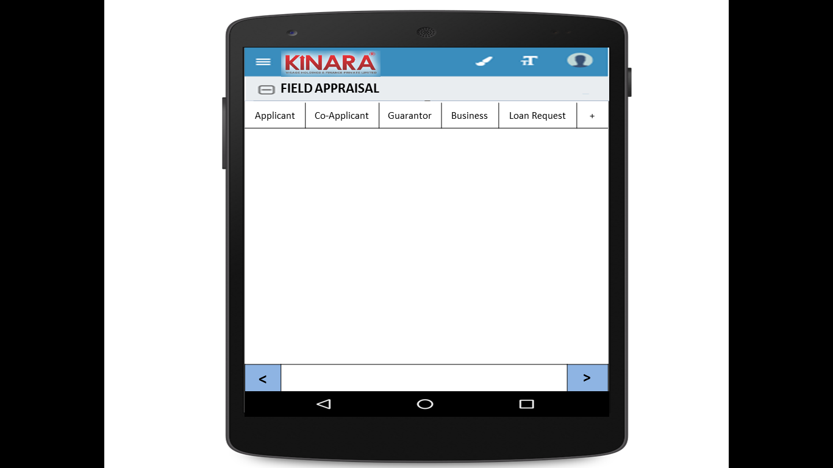

Click on the ‘+’ to add remarks at the end of the field appraisal

|  |  |
| --- | --- |
|  |  |

**4.2.1 Applicant**

Entity wise data capture will start with Applicant

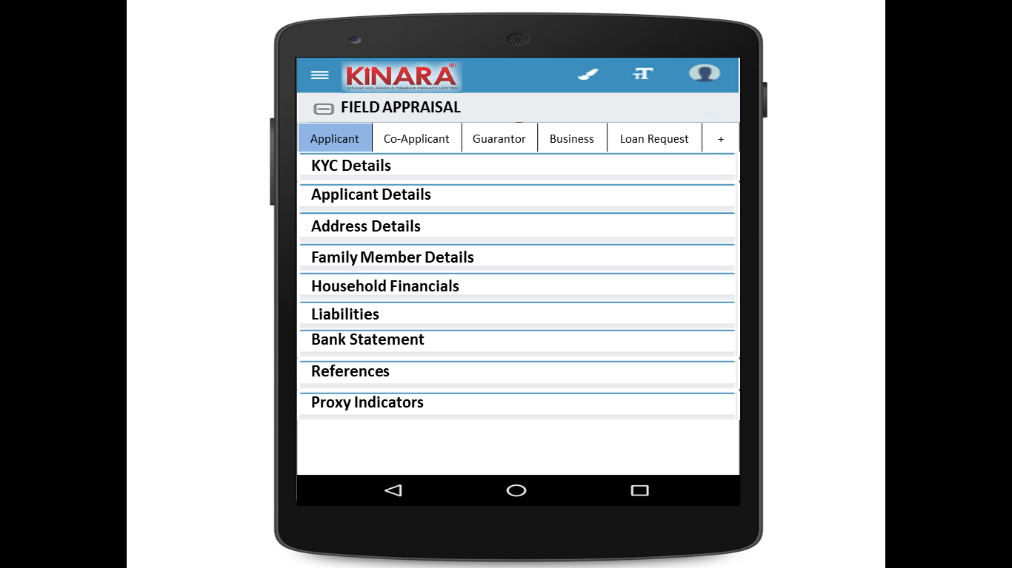

* + - 1. KYC Details:

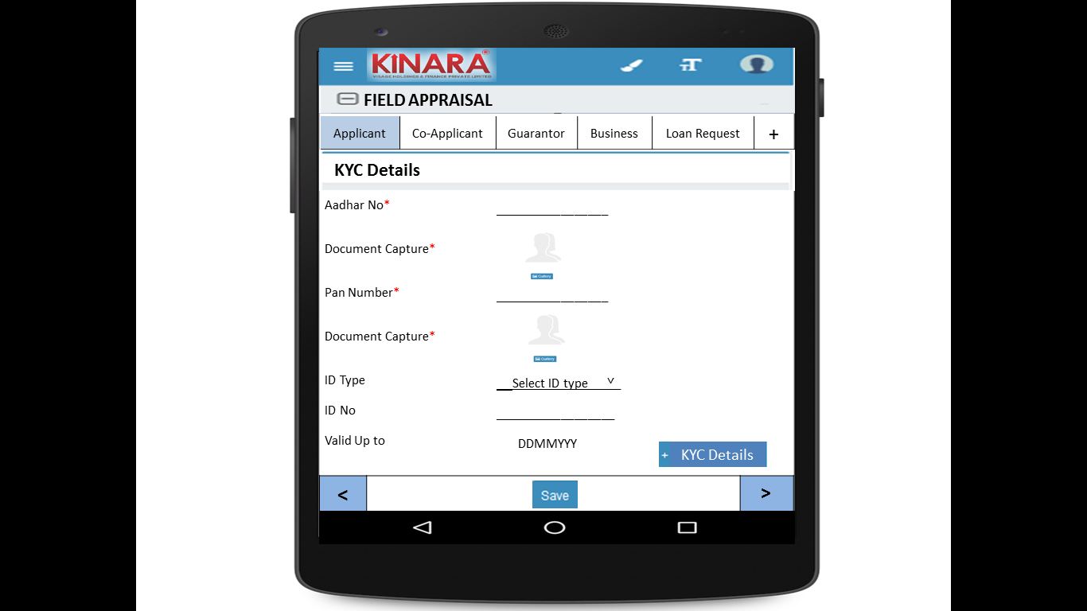

* + - 1. Applicant Details

|  |  |  |
| --- | --- | --- |
| Page 1 | Page 2 | Page 3 |

* + - 1. Address Details

|  |  |
| --- | --- |
| Page 1 | Page 2 |
| Page 3 | Page 4 |

* + - 1. Family Member Details

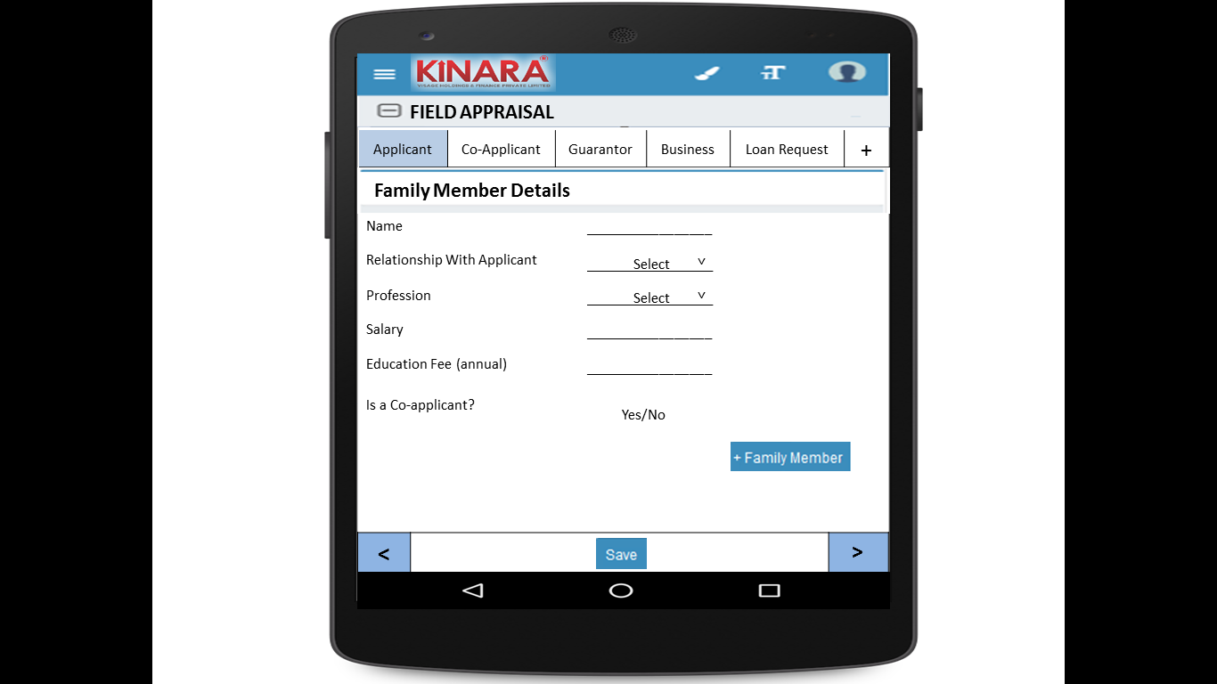

* + - 1. Household Financials

|  |  |
| --- | --- |
| Page 1 | Page 2 |

* + - 1. Liabilities

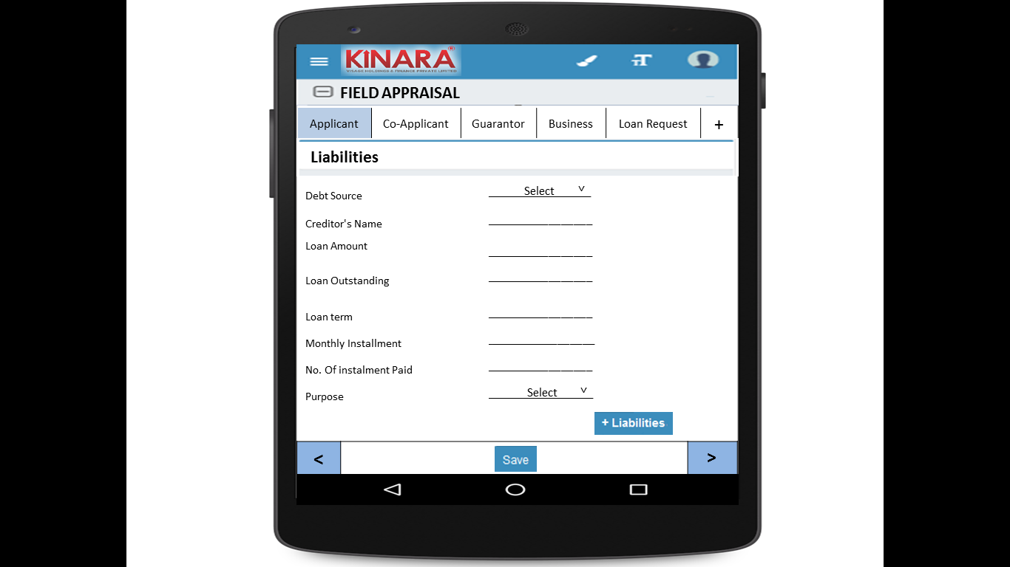

* + - 1. Bank Statement Details

|  |  |
| --- | --- |
| Page 1 | Page 2 |

* + - 1. References

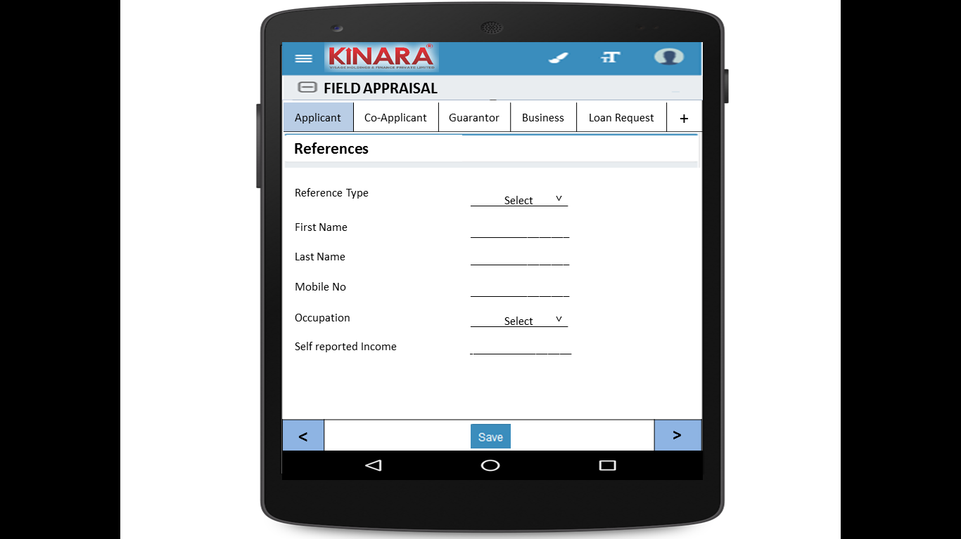

* + - 1. Proxy Indicators

|  |  |
| --- | --- |
| Page 1 | Page 2 |
| Page 3 | Page 4 |

* + 1. **Co-applicant**

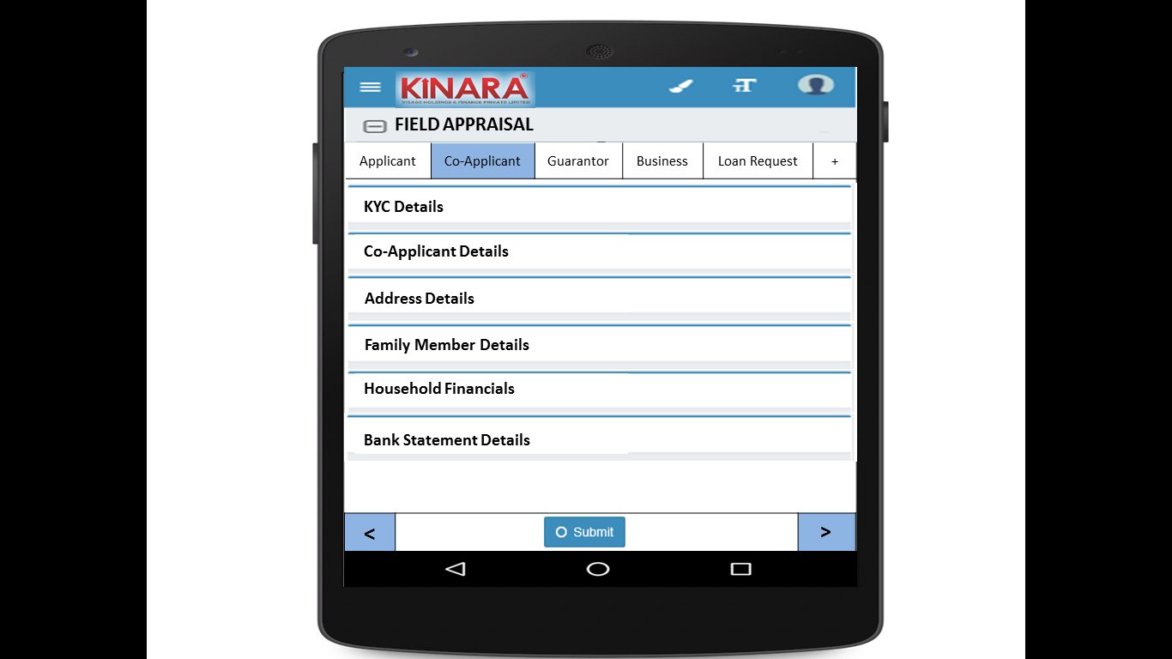

* + - 1. KYC Details

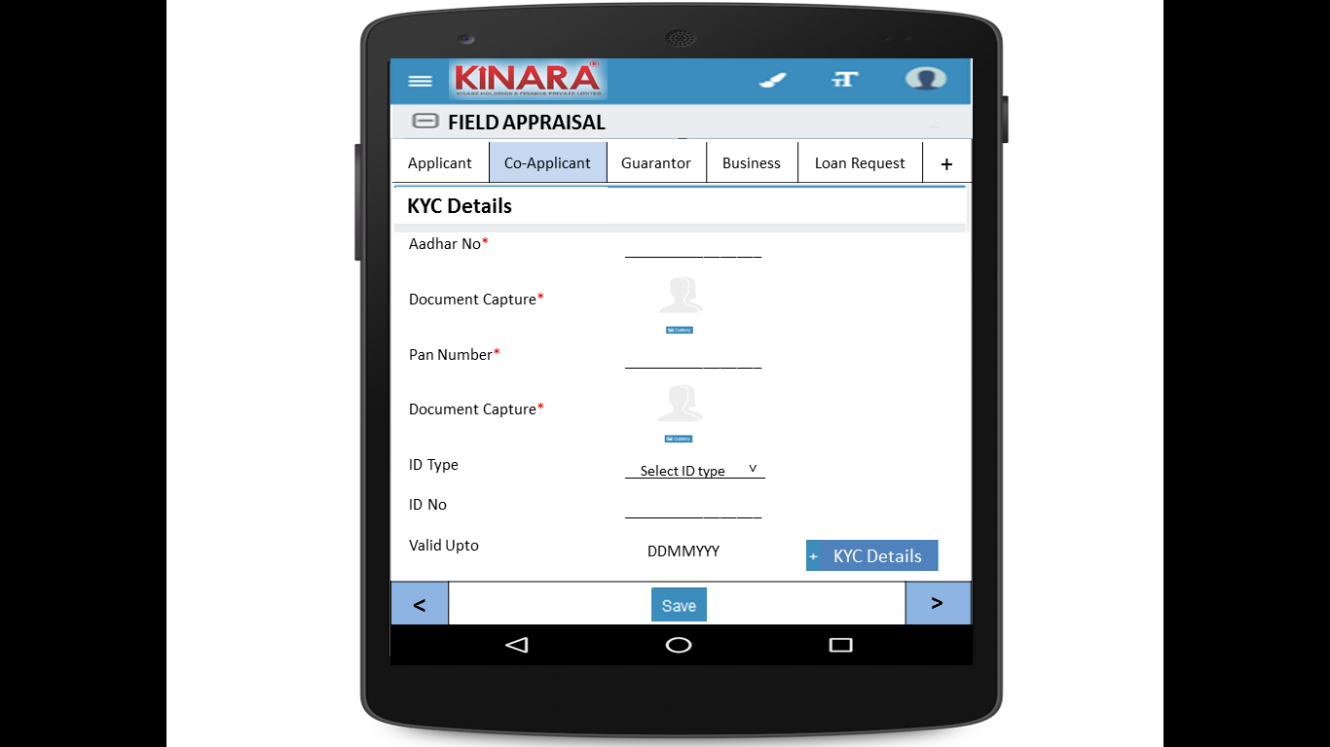

* + - 1. Co-applicant Details

|  |  |  |
| --- | --- | --- |
| Page 1 | Page 2 |  |

* + - 1. Address Details

|  |  |
| --- | --- |
| Page 1 | Page 2 |
| Page 3 | Page 4 |

* + - 1. Family Member Details

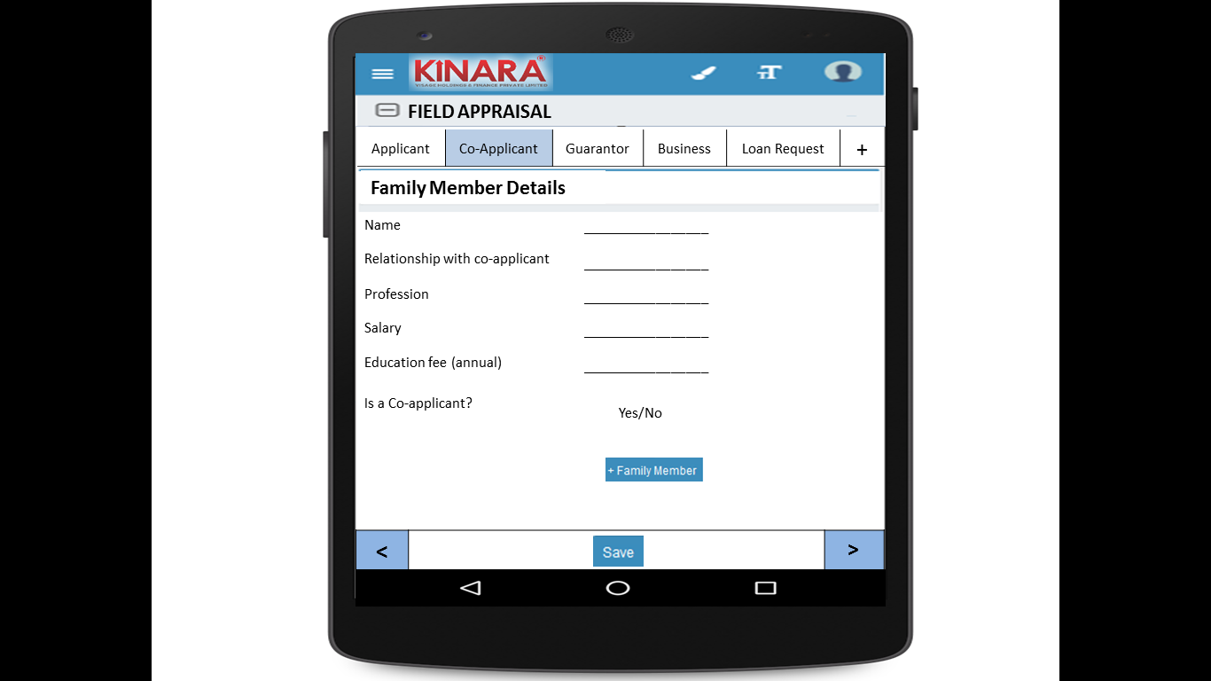

* + - 1. Household Financials

|  |  |
| --- | --- |
| Page 1 | Page 2 |

* + - 1. Bank Statement Details

|  |  |
| --- | --- |
| Page 1 | Page 2 |

* + 1. **Guarantor**

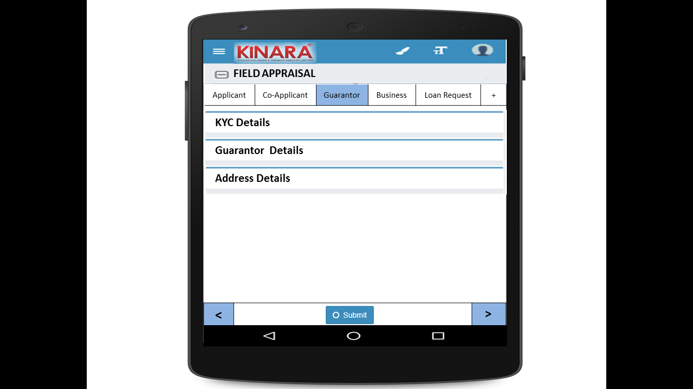

* + - 1. KYC Details

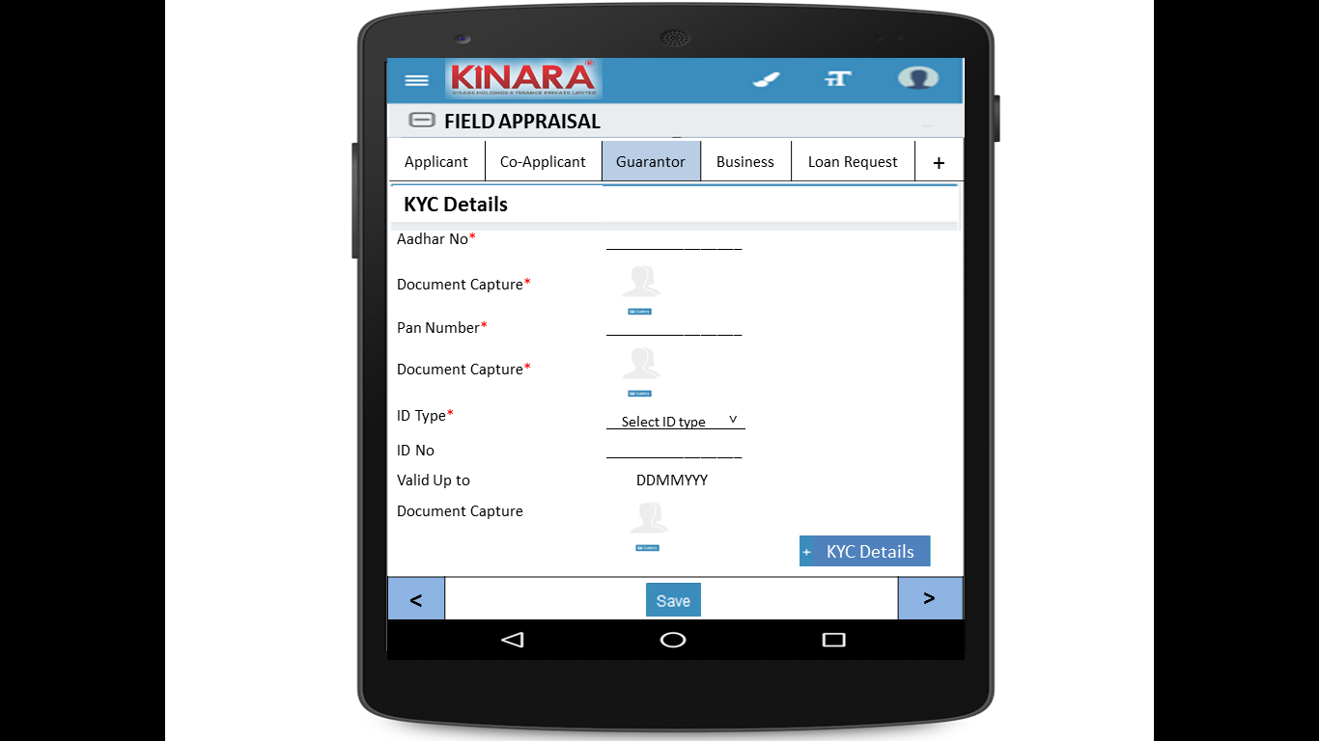

* + - 1. Guarantor Details

|  |  |  |
| --- | --- | --- |
| Page 1 | Page 2 | Page 3 |

* + - 1. Address Details

|  |  |
| --- | --- |
| Page 1 | Page 2 |
| Page 3 | Page 4 |

* + 1. **Business**

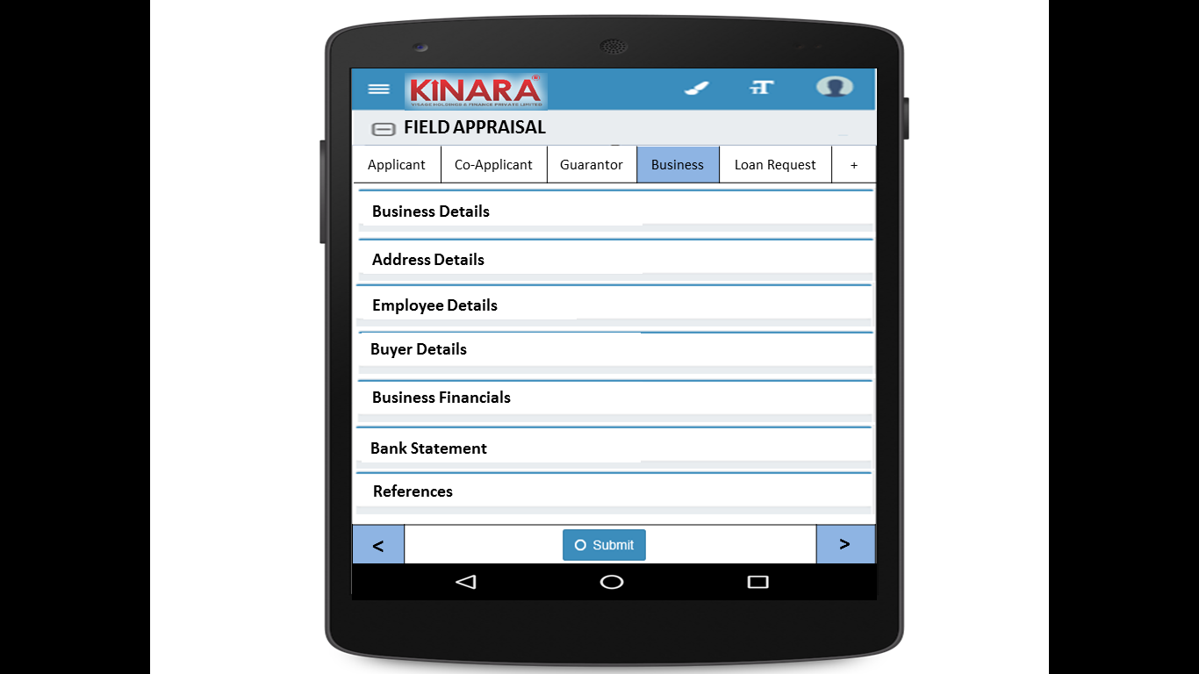

* + - 1. Business Details

|  |  |  |
| --- | --- | --- |
| Page 1 | Page 2 | Page 3 |

* + - 1. Address Details

|  |  |
| --- | --- |
| Page 1 | Page 2 |

* + - 1. Employee Details

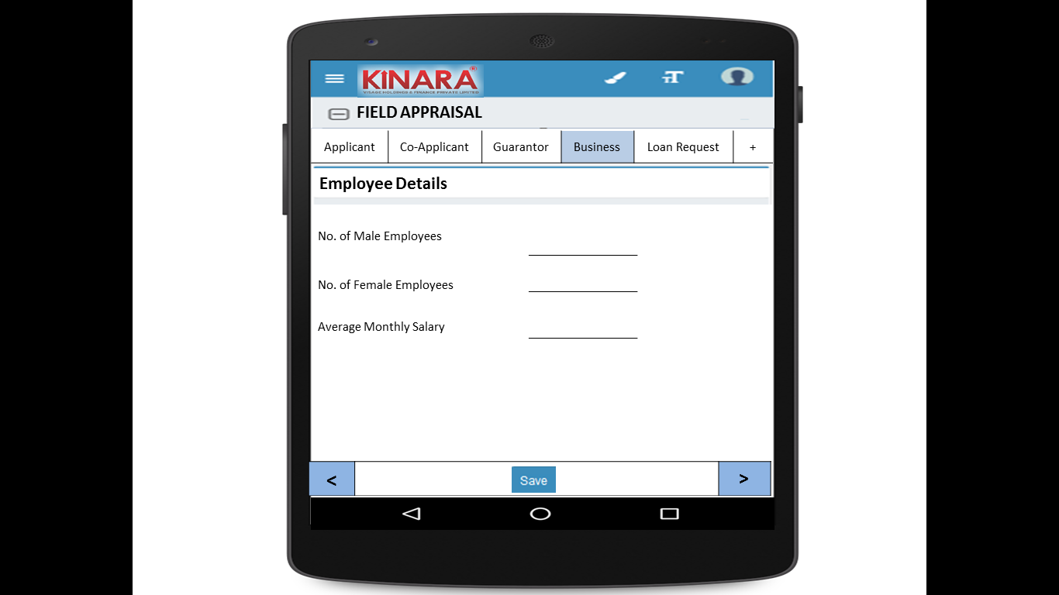

* + - 1. Buyer Details

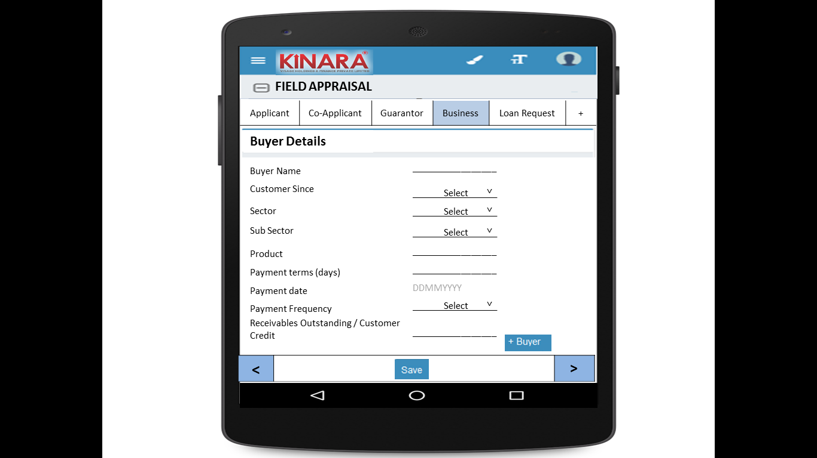

* + - 1. Business Financials

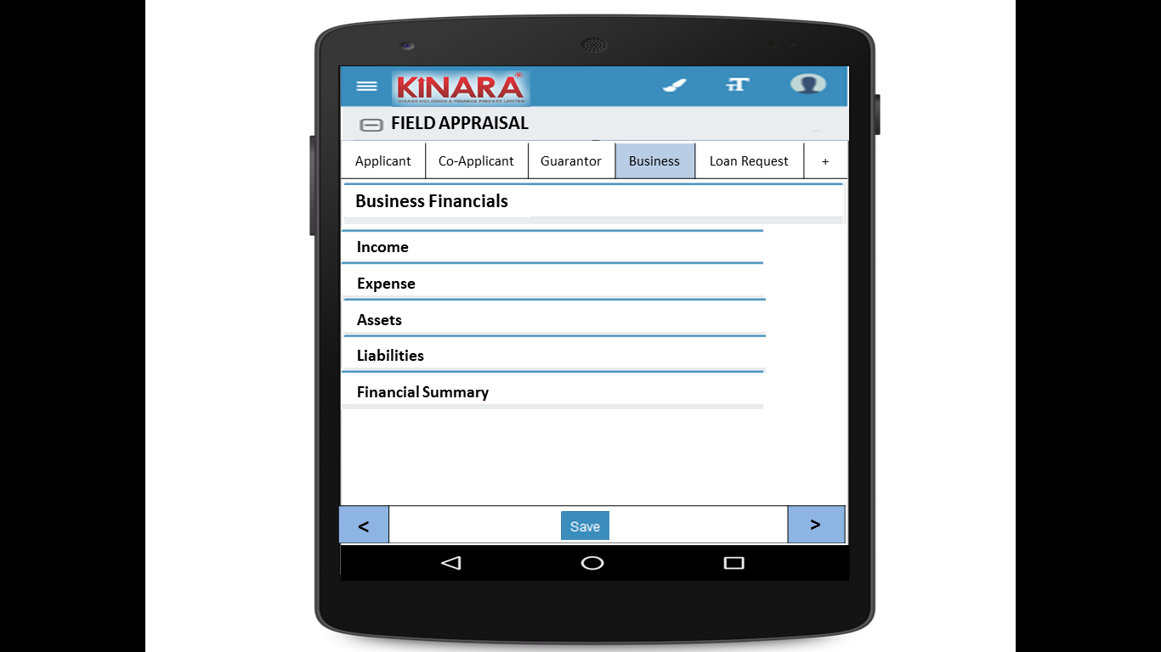

* + - * 1. Income

|  |  |
| --- | --- |
| Page 1 – Through Sales | Page 2 – Other Business Income |

* + - * 1. Expense

|  |  |
| --- | --- |
| Page 1- Raw material expense | Page 2 – Salary and wages |
| Page 3 – Fixed Obligations | Page 4 – Other Expenses |

* + - * 1. Assets

|  |  |
| --- | --- |
| Page 1 – Current Assets | Page 2 – Inventory |
| Page 3 – Machinery (1) | Page 4 – Machinery(2) |
| Page 5 – Other Assets | |

* + - * 1. Liabilities

|  |  |
| --- | --- |
| Page 1 – Fixed | Page 2 – Current |

* + - * 1. Financial Summary

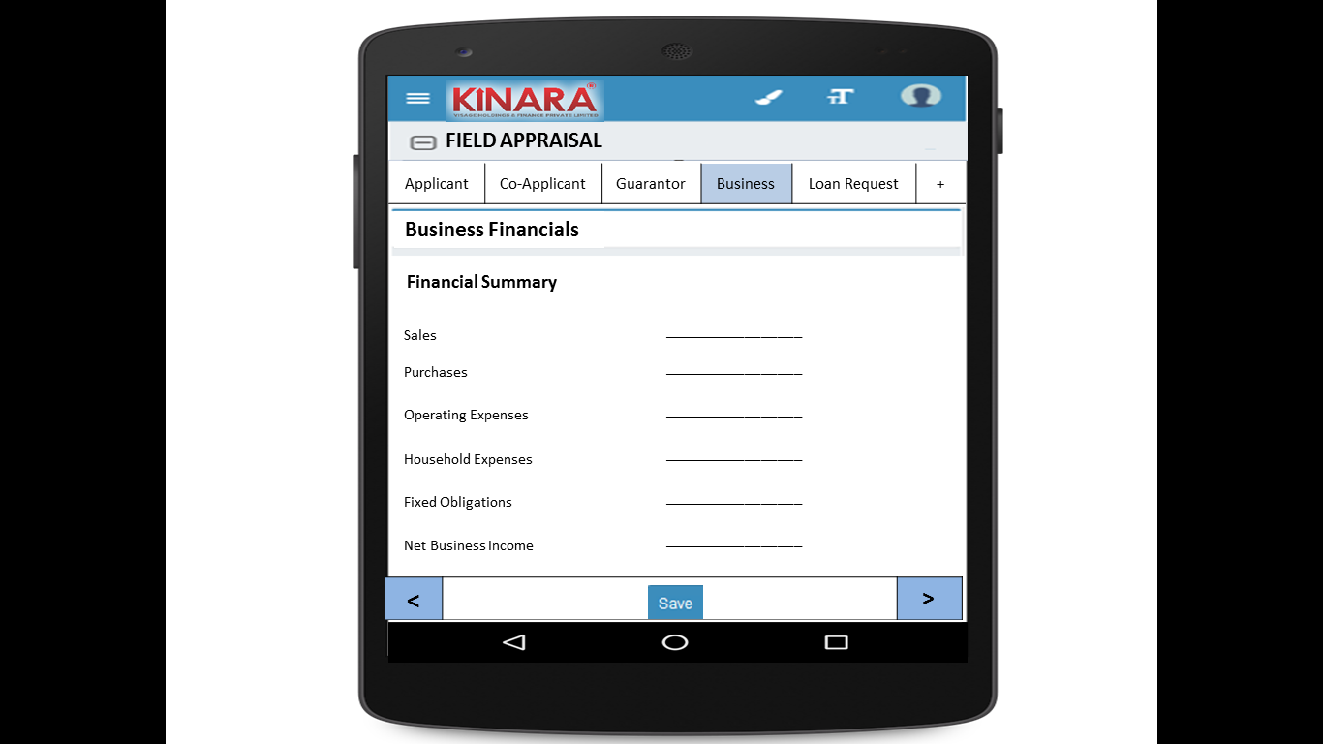

* + - 1. Bank Statement

|  |  |
| --- | --- |
| Page 1 | Page 2 |

* + - 1. References

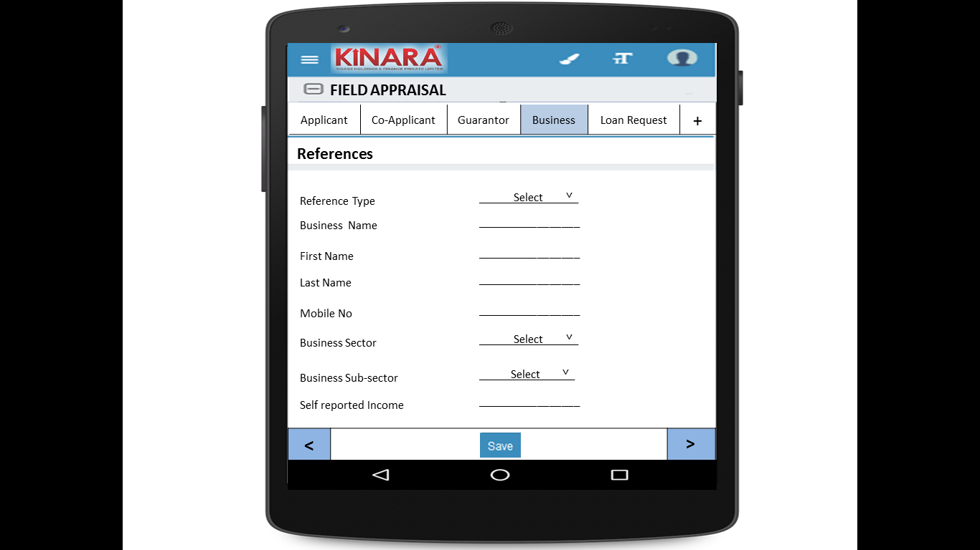

* + 1. **Loan Request**

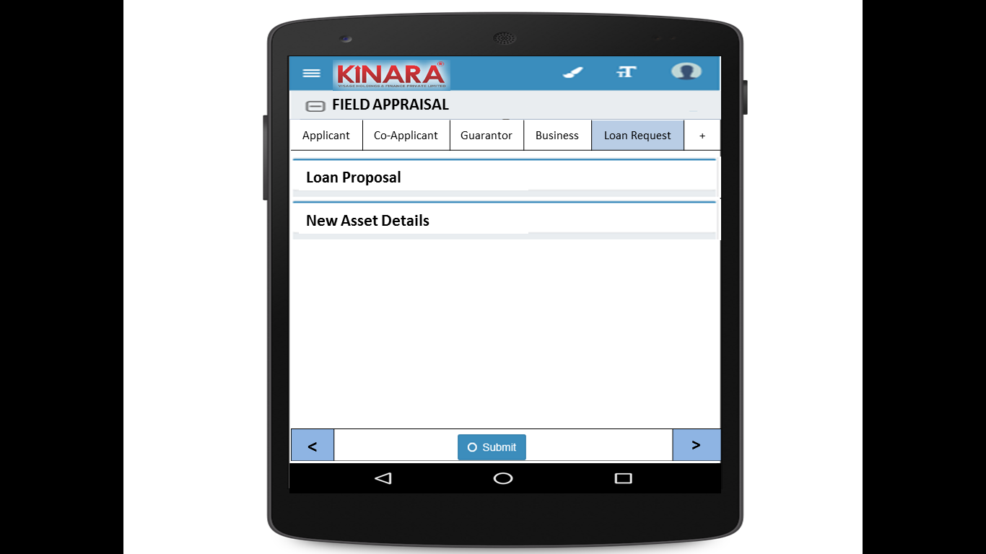

* + - 1. Loan Proposal

|  |  |
| --- | --- |
| Page 1 | Page 2 |

* + - 1. New Asset Details

|  |  |
| --- | --- |
| Page 1 | Page 2 |

## Functional requirements

* 1. Once the profile is selected from the field appraisal queue, the FRO captures the proxy indicators and remarks; and submits the profile to undergo calculation of risk score 2
  2. All loans with completed field appraisals will be sent for central credit review

## Uploads

-NA-

## Downloads

-NA-

## Reports

-NA-

# Risk Score 2

## UI specification

## Screenshot

## Functional requirements

## Upload

## Download

## Reports